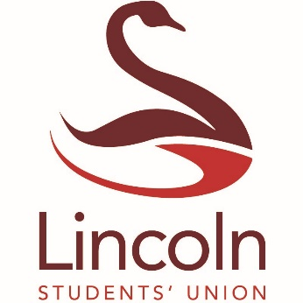

Student Conference Funding Guidance & Criteria
This scheme aims to provide both undergraduate and postgraduate students with an opportunity to present their work (oral or poster) at a conference (UK or International) and to support students in this process.
Individual awards will be made up of up to £500, which can be used to cover the costs of the conference registration, standard class travel and accommodation. The funding is subject to the abstract being accepted, and the Students’ Union reserve the right to negotiate the budget requested for the conference. Whilst applications will be required to be submitted at least 2 months in advance, you should not rely on being accepted when arranging to attend the conference. However, under certain circumstances we will consider applications submitted under the 2-month deadline.

Eligibility
To be eligible to apply, students must:
- Be an undergraduate or postgraduate student in the academic year 2019/2020
- Submit a fully completed application form and budget estimation and send any accompanying evidence to: academicopportunities@lincolnsu.com
- Not have access to any other University Research funding means, either from your School/College or Postgraduate funding, or give evidence that this avenue for funding has already been explored. All funding received will need to be specified and this may be investigated by the Students’ Union
- Have submitted their abstract to the conference, or have had their abstract fully accepted, with evidence submitted to academicopportunities@lincolnsu.com (email confirmation will be accepted as evidence)
- Apply for a conference being held at least 2 months in advance

Process
Applications must be submitted on the online application form via the Students’ Union website. They will then be considered and approved by the Student Conference Funding Panel, consisting of:
- A member from the University of Lincoln Students’ Union (e.g. the Vice President Education)
- A member from the Lincoln Academy of Learning and Teaching
- The Director of Research from the appropriate College
Students will receive confirmation of their application being sent to the Conference Funding Panel by the Student Voice Department. Please allow a period of 14 working days for an application to attend a conference in the UK to be reviewed, and up to 28 working days for an application to attend a conference outside of the UK to be reviewed. Decisions made by the Panel are final and cannot be appealed, however applications may be altered using feedback from the Panel and then resubmitted.
Funding is conditional until we receive evidence of the abstract being accepted by the conference.
Valid expenditure includes:
- Conference registration fees
- Standard class travel, or fuel costs if travelling by car
- Standard accommodation (for up to 2 nights - additional nights can be discussed should the conference be outside of the UK)
The Students’ Union reserve the right to query any expenditure that does not appear suitable, and will offer full support in finding cheaper alternatives if required.

Assessment
Applications will be considered and approved by the Student Conference Funding Panel. The Panel will give priority to students who:
- Clearly demonstrate how they meet the eligibility and assessment criteria
- Have not had a prior opportunity to present their work at an external conference
- Can demonstrate that the conference will have benefits to either their academic or professional development
Please be aware that the panel may seek additional information if necessary.

Payment
Successful applicants will be notified as soon as possible via their preferred email, with the total amount of funding to be provided. Students will be asked to provide their payment details either over email, or in person at the Students’ Union and payment will be processed using a Purchase Request Form. Please allow between 7-10 working days for payment to be processed, but do notify the Student Insight Assistant if you do not receive your funding after this period.
Alongside payment, successful applicants will be sent a copy of the ‘Student Conference Funding Guidance’ document which contains checklists, tips and Frequently Asked Questions to help prepare students to present at their chosen conference.

Feedback
Your feedback is important to us, therefore following the conference, we ask that you submit a short reflective report (max. 500 words) on your experience at the event and service from the Students’ Union. This will inform the programmes future development and allow for further promotional opportunities.

Please contact the Student Voice Department if you have any questions regarding the application or expenses process:
Amy O'Sullivan – AmOSullivan@lincoln.ac.uk – 01522 83 5322
academicopportunities@lincolnsu.com

